synopsis
on
Advanced monitoring and control mechanism for electric vehicle charging station using Machine learning

Submitted By
Vedika Peshane -31
Aditya Bhone - 39
Atharva Pophali-47
Atharva Fukey-48
Hariom Balang-57
Kiran Wande-103

Under The Guidance Of
Prof.N.U.Sambhe



Department Of Computer Technology
YESHWANTRAO CHAVAN COLLEGE OF ENGINEERING, Nagpur
Session 2024-2025

EXISTING METHODOLOGIES

1. Gradient Boosting (XGBoost, LightGBM)
For high-performance predictions like energy consumption and demand forecasting.
Accuracy: Combines multiple weak models to create a strong, accurate predictor.
Efficiency: Fast computation, handles large datasets effectively.
Feature Importance: Identifies key factors influencing charging behavior.

2. Random Forest (RF)
For fault detection and classification tasks in charging stations.
Robustness: Handles noisy data and prevents overfitting by using multiple decision trees.
Versatility: Works well with both classification (e.g., fault/no-fault) and regression tasks.
Imbalanced Data Handling: Effective for datasets with rare fault occurrences.

3. Support Vector Machine (SVM)
For fault classification and anomaly detection.
High Precision: Finds the best boundary (hyperplane) to separate normal and faulty sessions.
Effective in High Dimensions: Works well when dealing with complex data with many features.
Generalization: Performs well even with small datasets.

4. K-Means Clustering
For user segmentation, anomaly detection, and grid load balancing.
Unsupervised Learning: Groups similar charging behaviors without labeled data.
Pattern Recognition: Identifies high-demand clusters for optimized resource allocation.
Anomaly Detection: Detects unusual charging patterns that may indicate faults.

5. Tree-Based Models (Decision Trees, Gradient Boosting Trees)
For decision-making in load balancing and anomaly detection.
Simple and Interpretable: Easy to visualize how decisions are made.
Handles Non-Linear Data: Great for complex charging behavior patterns.
Fast Inference: Ideal for real-time applications.

6. Reinforcement Learning (RL)
For dynamic grid optimization and real-time charging control.
Real-Time Decision Making: Learns optimal strategies for energy distribution.
Adaptability: Continuously improves performance through feedback loops.
Optimizes Charging Efficiency: Manages power allocation dynamically.

Performance Metrics in EV Charging Project
performance metrics to evaluate the effectiveness of machine learning models:

1. Mean Absolute Error (MAE)
Measures the average absolute difference between predicted and actual values.
Simple to interpret—shows how much, on average, predictions deviate from actual values.
Less sensitive to outliers, making it reliable for consistent performance evaluation.
Energy consumption prediction to track average error in kWh.

2. Root Mean Squared Error (RMSE)
Measures the square root of the average squared differences between predicted and actual values.
Penalizes larger errors more heavily, making it ideal for applications where big mistakes are costly (e.g., power grid overload).
Highlights model performance on extreme values.
Demand forecasting and grid optimization to identify large prediction errors.

3. Mean Absolute Percentage Error (MAPE)
Shows the average percentage error between predicted and actual values.
Provides error as a percentage, making it easy to compare across different scales.
Effective for real-time monitoring, where relative errors are more important.
Charging session duration and load forecasting in dynamic environments.

4. R-Squared (R²) – Coefficient of Determination
Indicates how well the model explains the variance in the data.
Measures model accuracy—higher values (closer to 1) mean better performance.
Helps understand how well the model fits historical data.
Energy prediction models to assess how effectively the model explains variations in energy demand.

PROPOSED METHODOLOGY/ PROPOSED APPROACH (ALONG WITH BLOCK SCHEMATIC / USE CASE DIAGRAM ETC.)
The proposed methodology for EV Charging Demand Prediction focuses on developing a dynamic system that can accurately forecast energy demand at charging stations while adapting to changing usage patterns and grid requirements. The goal is to create a model that not only predicts current demand but also adjusts to real-time data and future growth in EV adoption.

1. Data Acquisition
The foundation of the EV charging demand prediction system.
- Historical Data Collection: Collects past data from charging stations, including session durations, energy usage, and user behavior patterns. The purpose is to train models on known trends and behaviors.
- Real-Time Data Integration: Ingests real-time data from IoT devices, smart meters, and EV chargers. This enables live demand forecasting and anomaly detection.
Flow: Start → Data Acquisition

2. Data Preprocessing
Prepares raw data for model training to ensure accuracy.
- Data Cleaning: Removes missing values, duplicates, and outliers to improve data quality for reliable predictions.
- Feature Engineering: Creates new features such as peak hours or weather impact to enhance model performance by extracting meaningful patterns from raw data.
- Feature Scaling: Normalizes data to a standard range, ensuring all features contribute equally during model training.
Flow: Data Acquisition → Data Preprocessing

3. Machine Learning Model Development
Core phase where predictive models are built.
- Model Selection: Chooses the best algorithms, like Random Forest or XGBoost, based on the dataset's characteristics. This ensures models are optimized for demand forecasting and grid stability.
- Training and Validation: Splits data into training and testing sets to evaluate performance, ensuring the model can generalize well to new data.
Flow: Data Preprocessing → Machine Learning Model Development

4. Model Evaluation and Refinement
Ensures the models are accurate and reliable.
- Evaluation Metrics: Measures performance using metrics such as Mean Absolute Error (MAE), Root Mean Square Error (RMSE), R², and Mean Absolute Percentage Error (MAPE). This quantifies the model’s accuracy.
- Model Refinement: Adjusts model hyperparameters, incorporates new data, and retrains models to improve performance over time.
Flow: Machine Learning Model Development → Model Evaluation and Refinement

5. Real-Time Prediction and Monitoring
Applies trained models to live data for dynamic predictions.
- Deploy Model: Deploys models in production environments, such as cloud servers or edge devices, enabling real-time predictions for EV demand.
- Implement Dashboard: Visualizes real-time predictions, energy consumption trends, and grid status, providing actionable insights for operators and users.
Flow: Model Evaluation and Refinement → Real-Time Prediction and Monitoring

6. Integration with Grid Management Systems
Aligns EV charging predictions with grid operations for efficient energy distribution.
- Demand Response Mechanisms: Adjusts energy distribution dynamically during peak and off-peak periods based on demand forecasts, optimizing grid load.
- Control Mechanisms: Automates charging schedules, load balancing, and voltage regulation to maintain grid stability even during high demand.
Flow: Real-Time Prediction and Monitoring → Integration with Grid Management Systems

7. Alarm and Feedback System
Monitors anomalies and gathers system and user feedback.
- Emergency Alerts: Sends real-time notifications for critical issues like grid overloads or equipment faults, ensuring system safety.
- User Feedback: Collects feedback from users about charging experiences and system performance to improve model accuracy and user satisfaction.
Flow: Integration with Grid Management Systems → Alarm and Feedback System

8. Scalability and Continuous Improvement
Ensures the system can evolve with growing EV demands and changing technology landscapes.
- System Scalability: Expands infrastructure to handle more data, charging stations, and users as the EV market grows.
- Continuous Improvement: Regularly updates machine learning models with new data, integrates new features, and enhances algorithms to maintain high performance.
Flow: Alarm and Feedback System → Scalability and Continuous Improvement → End

Flow Summary
Start → Data Acquisition → Data Preprocessing → Machine Learning Model Development → Model Evaluation and Refinement → Real-Time Prediction and Monitoring → Integration with Grid Management Systems → Alarm and Feedback System → Scalability and Continuous Improvement → End

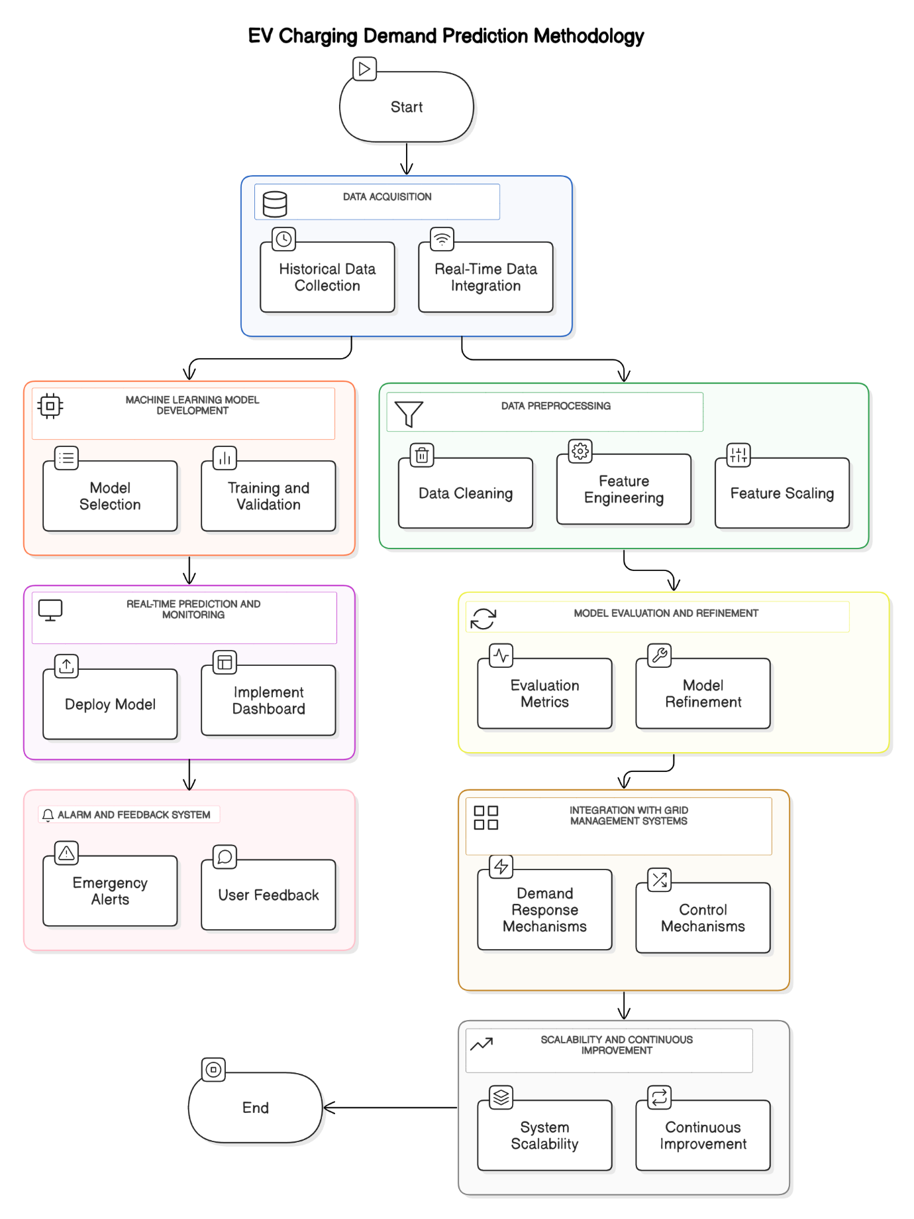

IMPLICATIONS (EXPECTED OUTCOMES) AND EXPECTED CHAPTER SCHEME OF THE PROPOSED WORK.
IMPLICATIONS (EXPECTED OUTCOMES)

The primary goal of this project is to develop an intelligent, data-driven system that optimizes EV charging operations, enhances grid stability, and ensures efficient energy distribution. The system will not only predict energy demand accurately but also adapt to real-time changes and support smart grid integration.

1. Accurate EV Charging Demand Prediction
- Outcome:
A machine learning model capable of accurately forecasting energy demand for EV charging stations based on historical and real-time data.
- Impact:
Reduces the risk of overloading the grid during peak hours.
Enables proactive energy management for both utility providers and charging station operators.
Improves resource planning for future EV infrastructure development.

2. Dynamic Voltage and Current Optimization
- Outcome:
A system that dynamically adjusts voltage and current settings based on real-time demand, ensuring faster and safer charging while protecting battery health.
- Impact:
Improves charging efficiency, reducing the overall charging time for EVs.
Prevents battery degradation by maintaining optimal charging parameters.
Supports adaptive charging, adjusting to different vehicle types and user preferences.

3. Real-Time Fault Detection and Anomaly Management
- Outcome:
An integrated fault detection system that identifies anomalies in charging behavior, such as voltage fluctuations, current overloads, or potential hardware failures.
- Impact:
Minimizes downtime by detecting faults early and triggering real-time alerts.
Enhances system reliability and reduces maintenance costs.
Protects both the grid infrastructure and EV batteries from potential damage.

4. Optimized Grid Load Management
- Outcome:
A system that integrates with grid management to optimize energy distribution, especially during peak demand periods.
- Impact:
Reduces energy costs through efficient load balancing.
Enhances grid stability, preventing power outages or overloads.
Supports the implementation of demand response programs for better grid flexibility.

5. Real-Time Monitoring and Data Visualization
- Outcome:
An interactive dashboard for real-time monitoring of EV charging activity, energy consumption, system performance, and grid status.
- Impact:
Provides real-time insights to operators for better decision-making.
Helps users track their charging status, session history, and costs.
Facilitates data-driven analytics for continuous system improvement.

6. Emergency Alert and Feedback System
- Outcome:
A robust alarm system that sends real-time notifications during critical events like grid overload, hardware faults, or abnormal charging patterns.
- Impact:
Increases safety by alerting users and operators about potential issues.
Ensures quick response to emergencies, reducing the risk of system failures.
Collects user feedback to improve service quality and system performance.

7. Scalability for Growing EV Infrastructure
- Outcome:
A system designed for scalability, capable of handling an increasing number of EVs, charging stations, and diverse geographic locations.
- Impact:
Future-proofs the system as EV adoption grows globally.
Supports multi-station networks with centralized monitoring and control.
Reduces the cost of expanding infrastructure through modular system design.

EXPECTED CHAPTER SCHEME OF THE PROPOSED WORK

CHAPTER 1: INTRODUCTION
- Overview of Electric Vehicle (EV) technology and the growing demand for smart charging infrastructure
- Challenges in EV charging, grid load management, and energy optimization
- Importance of predictive models for efficient energy distribution
- Objectives and scope of the project focusing on real-time demand forecasting and grid stability

CHAPTER 2: LITERATURE REVIEW
- Review of existing EV charging demand prediction methodologies
- Machine learning techniques used in energy demand forecasting and grid optimization
- Analysis of fault detection and anomaly management in smart grids
- Identified research gaps in current EV charging management systems

CHAPTER 3: EXISTING METHODOLOGIES
- Overview of traditional methods for energy forecasting and load management
- Analysis of widely used models such as Random Forest, SARIMAX, K-Means Clustering, and Queue Models
- Limitations of current prediction models in handling real-time data and scalability challenges

CHAPTER 4: PROPOSED METHODOLOGY
- Description of the proposed EV charging demand prediction framework
- Machine learning models and techniques implemented (XGBoost, Random Forest, SVM, Reinforcement Learning)
- System architecture, workflow, and data flow diagrams for real-time monitoring and grid integration

CHAPTER 5: IMPLEMENTATION AND EXPERIMENTATION
- Data acquisition from real-time EV charging stations and historical datasets
- Data preprocessing techniques including cleaning, feature engineering, and scaling
- Model training, hyperparameter tuning, and performance evaluation metrics (MAE, RMSE, R²)
- Implementation of real-time monitoring dashboards and grid optimization algorithms

CHAPTER 6: RESULTS AND DISCUSSION
- Performance analysis of the proposed prediction models
- Comparison with existing demand forecasting and grid management techniques
- Evaluation of real-time efficiency, scalability, and adaptability under dynamic charging conditions

CHAPTER 7: CONCLUSION AND FUTURE SCOPE
- Summary of key findings, outcomes, and the system’s impact on smart grid management
- Limitations of the current approach and potential areas for improvement
- Future research directions for integrating renewable energy, enhancing fault detection, and improving grid resilience

REFERENCES (As per IEEE format)

- Almaghrebi, A.; Aljuheshi, F.; Rafaie, M.; James, K.; Alahmad, M. Data-Driven Charging Demand Prediction at Public Charging Stations Using Supervised Machine Learning Regression Methods. Energies 2020, 13, 4231. https://doi.org/10.3390/en13164231
- Shufian, Abu & Hannan, Nasif & Emon, Mukter Hossain & Kabir, Shaharier & Fattah, Shaikh Anowarul & Hossain, Md Sajid. (2024). Automatic Fault Detection and Analysis Of Electric Vehicle Charging Station by Machine Learning. 10.1109/TENSYMP61132.2024.10752256.
- S. Shahriar, A. R. Al-Ali, A. H. Osman, S. Dhou and M. Nijim, "Prediction of EV Charging Behavior Using Machine Learning," in IEEE Access, vol. 9, pp. 111576-111586
- K. N. B. S. Hitesh, P. S. Teja and J. R. Kumar, "Electric Vehicle Charging Demand Prediction using Machine Learning Algorithms," 2024 8th International Conference on Inventive Systems and Control (ICISC), Coimbatore, India, 2024, pp. 47-54, doi: 10.1109/ICISC62624.2024.00015.
- Aghsaee, R.; Hecht, C.; Schwinger, F.; Figgener, J.; Jarke, M.; Sauer, D.U. Data-Driven, Short-Term Prediction of Charging Station Occupation. Electricity 2023, 4, 134-153. https://doi.org/10.3390/electricity4020009
- S. M. S and R. Gunabalan, "Enhancement of Charging Efficiency of Batteries for Electric Vehicles: Review," 2022 Fourth International Conference on Emerging Research in Electronics, Computer Science and Technology (ICERECT), Mandya, India, 2022, pp. 1-6, doi: 10.1109/ICERECT56837.2022.10060243.
- S. Deb, "Machine Learning for Solving Charging Infrastructure Planning: A Comprehensive Review," 2021 5th International Conference on Smart Grid and Smart Cities (ICSGSC), Tokyo, Japan, 2021, pp. 16-22, doi: 10.1109/ICSGSC52434.2021.9490407.
- M. Straka, R. Carvalho, G. V. D. Poel and L. Buzna, "Analysis of Energy Consumption at Slow Charging Infrastructure for Electric Vehicles," in IEEE Access, vol. 9, pp. 53885-53901, 2021, doi: 10.1109/ACCESS.2021.3071180.
- A. Shufian, N. Hannan, M. M. Hossain Emon, S. Kabir, S. A. Fattah and M. S. Hossain, "Automatic Fault Detection and Analysis Of Electric Vehicle Charging Station by Machine Learning," 2024 IEEE Region 10 Symposium (TENSYMP), New Delhi, India, 2024, pp. 1-6, doi: 10.1109/TENSYMP61132.2024.10752256.
- R. Atallah et al., "Quality of Service Evaluation and Forecast for EV Charging Based on Real-World Data," 2023 19th International Conference on Wireless and Mobile Computing, Networking and Communications (WiMob), Montreal, QC, Canada, 2023, pp. 280-285, doi: 10.1109/WiMob58348.2023.10187855.
- S. Shahriar, A. R. Al-Ali, A. H. Osman, S. Dhou and M. Nijim, "Machine Learning Approaches for EV Charging Behavior: A Review," in IEEE Access, vol. 8, pp. 168980-168993, 2020, doi: 10.1109/ACCESS.2020.3023388.
- M. Shukla, D. K. Singh, A. Yadav, A. K. Singh, N. A. Jumaa and A. Mohammed, "Optimizing Electric Vehicle Charging Station Placement in Urban Areas: A Data-Driven Approach," 2023 3rd International Conference on Advance Computing and Innovative Technologies in Engineering (ICACITE), Greater Noida, India, 2023, pp. 2835-2838, doi: 10.1109/ICACITE57410.2023.10183075.
- A. Palaniappan, P. Bhukya, S. K. Chitti and J. Gao, "Data-Driven Analysis of EV Energy Prediction and Planning of EV Charging Infrastructure," 2023 IEEE Ninth International Conference on Big Data Computing Service and Applications (BigDataService), Athens, Greece, 2023, pp. 17-24, doi: 10.1109/BigDataService58306.2023.00009

